Lab 3: Variability and Z-Scores

This lab will again use data from the 2013 Pan-Canadian Assessment Program (PCAP) developed by the Council of Ministers of Education, Canada. In the previous lab, we ran some descriptive statistics on students’ demographic and performance data to become familiar with the data set. In this lab, we will focus on the performance data to better understand those scores.

Although we did not collect this data ourselves, we can still become familiar with the types of questions that were asked (through the questionnaire and codebook) and the characteristics of the data (through descriptive statistics). In many research studies, we are often not involved with the research, design, and data collection aspects of the investigation, but we are still able to analyze the data!

1. Thinking about the ranges
The first step when working with a data set is to understand the data for that variable. Please create a descriptive table that includes the mean, standard deviation, variance, range, minimum, maximum, and standard error mean for students’ academic achievement in science, math, and reading, including all the relevant subscores. *Please ensure your student weights are used throughout the analyses.*
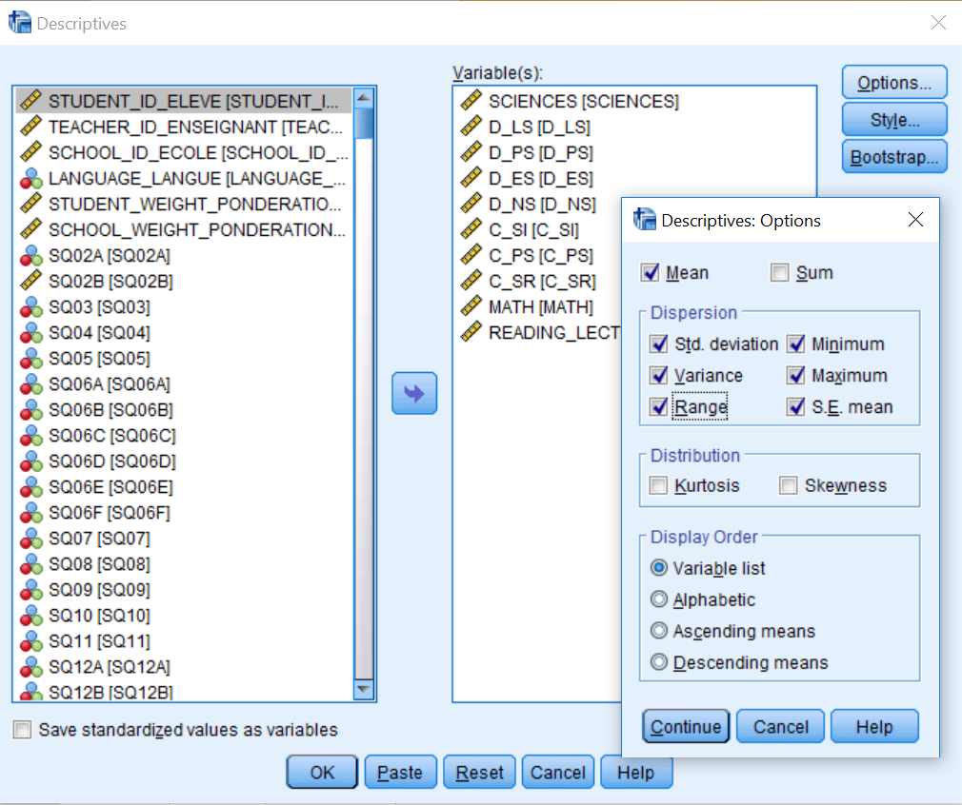
The table below may be helpful as you develop your table.
Table 1.
Title (please make a title for this table)
 | Mean | Standard Deviation | Variance | Range | Minimum | Maximum | Standard Error Mean
Science
Life Science
Physical Science
Etc. | Etc. | Etc. | Etc. | Etc. | Etc. | Etc. | Etc.
Questions:
- Please describe your sample size. Include an explanation of how many students actually completed the PCAP test and how many people are represented in Table 1.
- What does Standard Error Mean represent? This value is commonly reported as descriptive statistics in many quantitative publications; why is this value important? (You may need to use Google for this item.)
- What does an overall Science score of 500 on the test represent? (You may need to consult the technical report for this item.)
- What does an overall Science score of 500 indicate in terms of the student’s standings when compared to their Alberta peers?

2. Standardized scores
The scale that PCAP uses to represent students’ scores on the test is one way to represent achievement. However, there are other standardized ways to represent scores, such as the use of z-scores. Now, let’s learn how to compute standard z-scores for the students’ academic achievement in science, math, and reading, including all the relevant subscores. Click Analyze → Descriptive Statistics → Descriptives. Select all the variables you are interested in by clicking on them, then bring them over to the Variable(s) box by clicking on the arrow. Select option “Save standardized values as variables” (located on the bottom left) by clicking on the box (make sure the box is checked). Click OK.
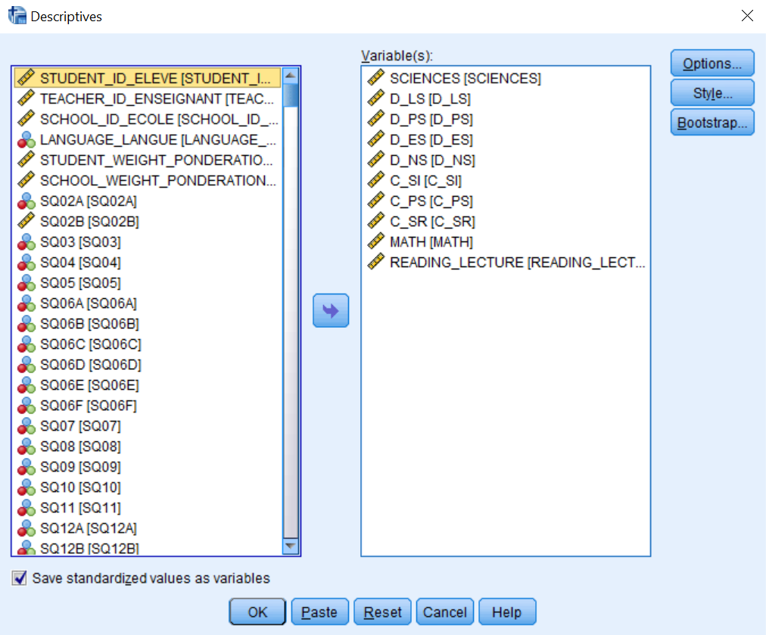
If you scroll to the last columns of the SPSS spreadsheet, you will notice NEW variables with the letter Z in front of them (e.g., ZSCIENCE). These are your new standardized z-scores for each of the achievement score variables. Please create a descriptive table that includes the mean, standard deviation, variance, range, minimum, maximum, and standard error mean for the standardized z-scores of students’ academic achievement in science, math, and reading, including all the relevant subscales.
Questions:
- Using the science z-scores, please answer the following questions:
a) What are the smallest and the largest standardized z-scores?
b) How many standard deviation units from the mean is the largest score?
c) Select females only (Data→ Select cases → If gender = 2). What is their average standard z-score?
d) On average, do females perform better or worse than males in this sample? If there is a difference between the two groups, how much of a difference exists?

3. Developing other standardized scales
There are many standardized scales that are used. For example, IQ scores have a mean of 100 and a standard deviation of 15; these values are often contested in the literature, because some scholars believe they should be updated and different for each country. We will simulate a set of IQ data for the students. To do so, go to: Transform → Compute Variable → Write IQ_Scale in the left Target Variable box and write norm(15)+100 in the right Numeric Expression box. (These instructions generate a random sample from a normal distribution with a mean of 100 and a standard deviation of 15.)
Now, calculate some descriptives and make a histogram of IQ with a normal curve superimposed on it. Analyze → Descriptive Statistics → Frequencies → Statistics → Check mean, median, mode, standard deviation, variance and skewness → Go to Charts → Check Histograms → Click on Show normal curve on histogram. (We can superimpose a normal curve on each of the histograms.) → Click Continue and OK
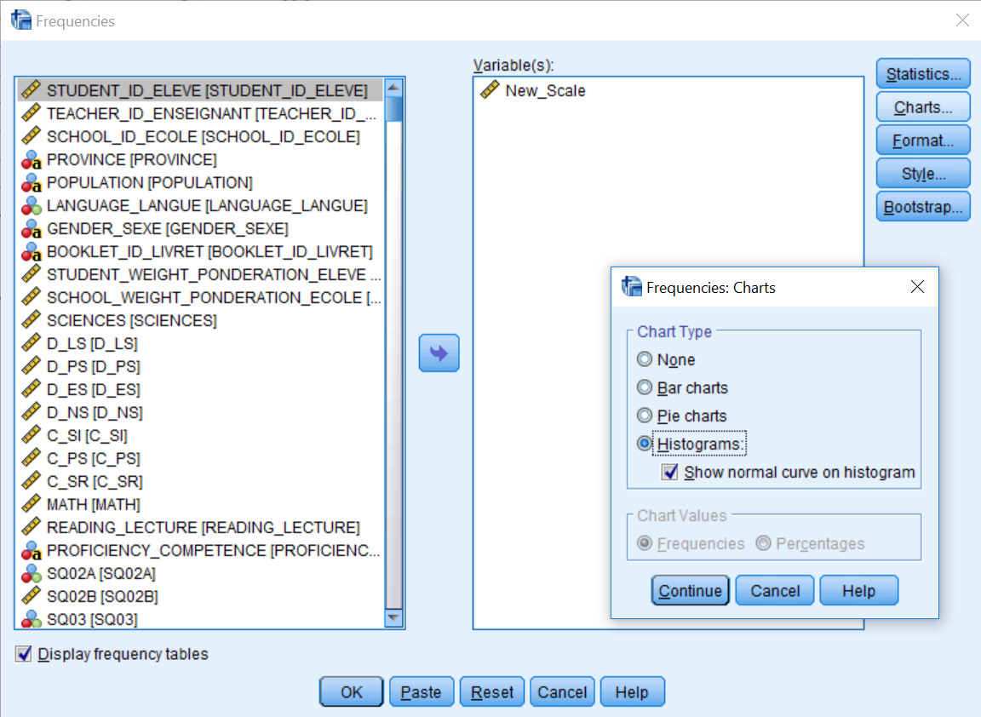
Questions:
- Assuming IQ_Scale is exactly normally distributed, what percentage of cases should have values between 70 and 130? (You may want to refer to the Z-distribution table in your textbook.)
- What percentage of cases in your sample have IQ values in this range? (Hint: use the Cumulative Percent column from your SPSS output; you may not have values 70 and 130 exactly, so pick the closest value.)
- What percentage of the cases would you expect to have IQ values of 115 or more, if IQ is exactly normally distributed?
- What percentage of cases in your sample have IQ values greater than 115?

Now convert your IQ scores into z-scores using the steps presented in 2. Standardized scores.
Questions:
- What percentage of cases would you expect to have standard scores between -2 and +2?
- What percentage of your sample have standardized scores greater than +1?
- What similarities or differences do you notice in your answers for questions 7 & 10 as well as 8 & 11? Please explain these similarities or differences.

You have now completed the lab.

